Fuchsias for Mom…and Beyond!

By Corina Reynolds Stearns, Portland Nursery

Of the many enduring trends in the world of gift plants, one that enjoys consistent popularity is the grand old Mother’s Day Fuchsia basket. They are a common sight in nurseries each late spring: those overflowing big, bright buds just daring you to reach out and pop them. Although many of us are used to seeing one particular style of Fuchsia, they really run the gamut: from those frilly, rubenesque, prom-dress style blooms, to pendant-like jewels that would be perfectly well-suited as an elegant lady’s earring. The color choices can range from combinations of purple, magenta, soft pink, red, white, coral orange, and, well...fuchsia! Pro tip: the outer layer of the flower is called the sepal, and the inner part is the corolla. So you might see descriptions that read something like: “pink sepal/purple corolla”. Now you know! Another fun fact: fuchsias are edible! You can eat the flowers, and their berries taste quite peppery. Please note, however, that growers may treat plants with products that you wouldn’t want to eat, so *only* harvest from established plants that you know have not been treated!

Fuchsias come in a range of growing habits. Those commonly planted in hanging baskets are described as *trailing*. Their habit is lax, but make no mistake: they are true woody shrubs. Planted out, trailing Fuchsias would create a kind of ground cover effect. Non-trailing Fuchsias are generally referred to as *upright*. Most upright varieties stay in the 3’ tall and wide range, though there are many exceptions. One of the biggest upright Fuchsias out there is ‘Cardinal’, which, when happy in rich, moist soil, can reach 8’ tall! You’ll also find “semi-upright” styles, and a few vine-like varieties.

As for care, Fuchsias do best with part shade and consistent watering. Think cool—morning sun is best—avoid blazing hot situations or afternoon sun. They can grow in deep shade, but generally will not flower very well. Potted Fuchsias really never like to dry out, and watering every day in summer is usually necessary. Adding water-holding products to the soil can help. Fuchsias will also perform best with consistent fertilizer. A bi-weekly feeding of liquid bloom formula such as Fox Farm brand “Big Bloom” is a good choice.

Many of us think of Fuchsias as annuals, to be enjoyed for a summer and discarded at the end of the season. But most are quite hardy in the Portland area! So, if you have a prize hanging basket specimen, try up-potting it, or planting it in the ground in the late summer or early fall. You can plant them deeply (like a tomato) and mulch them well for extra winter protection, or move containers into a sheltered location when frost threatens. They will lose their leaves, and be later to flower next year, but they’ll often survive, and you’ll have a wonderful perennial plant to look forward to every year!

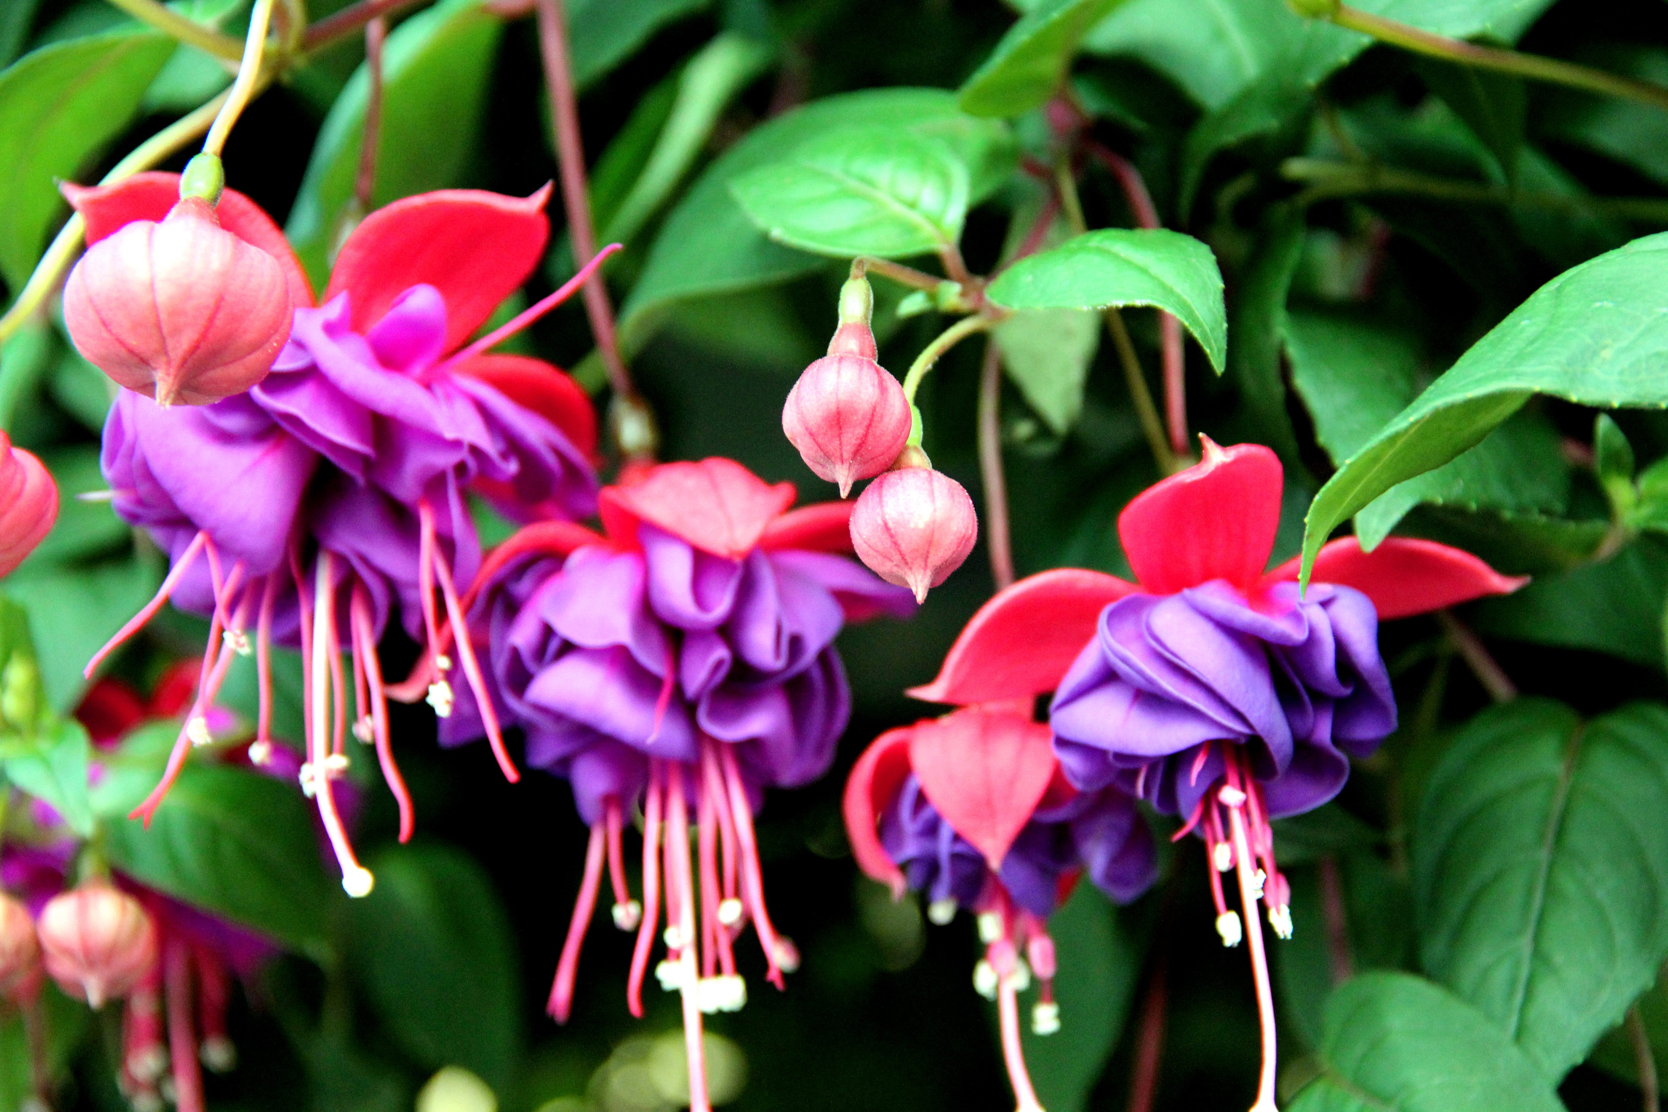

*Fuchsia* ‘Dark Eyes’

Photos by Sara Ori

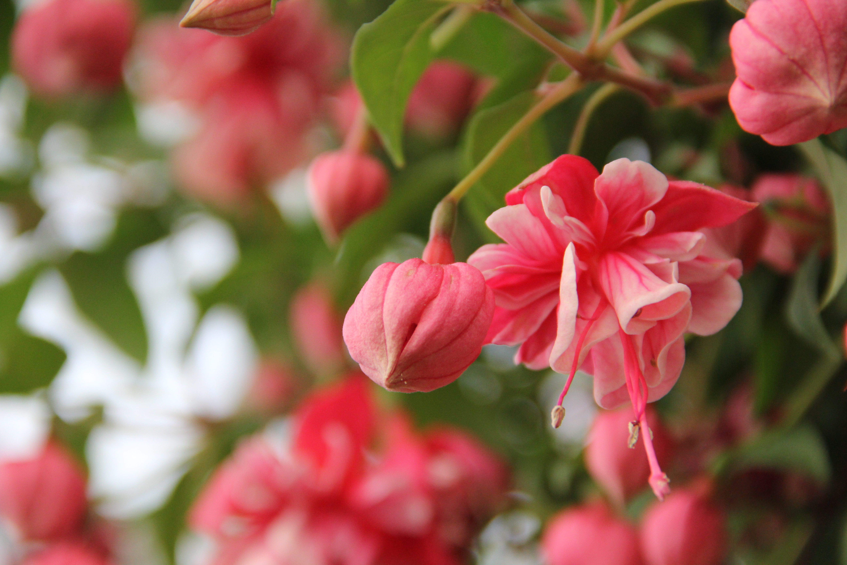

*Fuchsia* ‘R.A.F’